1989 年 AMC 8 真题与解答
American Mathematics Competitions 8 · 中英双语
共 25 题，限时 40 分钟；单项选择题，每题 1 分，答错不扣分，满分 25 分。
内容来源：LIVE by Po-Shen Loh（live.poshenloh.com）历年 AMC 8 真题与解答，试题经美国数学协会（MAA）官方授权使用；本文档由本地整理生成，供个人学习使用，版权归原作者及 MAA 所有。
编排说明：第一部分为题目（先中文、后英文原题），第二部分为解答与答案，便于先做题后对答案。
第一部分 题目
第 1 题
下列表达式的值是多少？
(1 + 11 + 21 + 31 + 41) + (9 + 19 + 29 + 39 + 49)
（A）150 （B）199 （C）200 （D）249 （E）250
English
What is the value of
(1 + 11 + 21 + 31 + 41) + (9 + 19 + 29 + 39 + 49)?
(A) 150 (B) 199 (C) 200 (D) 249 (E) 250
第 2 题
下列表达式的值是多少？
2/10 + 4/100 + 6/1000
（A）0.012 （B）0.0246 （C）0.12 （D）0.246 （E）246
English
What is the value of
2/10 + 4/100 + 6/1000?
(A) 0.012 (B) 0.0246 (C) 0.12 (D) 0.246 (E) 246
第 3 题
下列哪个数最大？
（A）0.99 （B）0.9099 （C）0.9 （D）0.909 （E）0.9009
English
Which of the following numbers is the largest?
(A) 0.99 (B) 0.9099 (C) 0.9 (D) 0.909 (E) 0.9009
第 4 题
下列哪个数最接近
401/0.205。
（A）0.2 （B）2 （C）20 （D）200 （E）2000
English
Estimate to determine which of the following is closest to
401/0.205.
(A) 0.2 (B) 2 (C) 20 (D) 200 (E) 2000
第 5 题
下列表达式的值是多少？
-15 + 9 × (6 ÷ 3)
（A）-48 （B）-12 （C）-3 （D）3 （E）12
English
What is the value of
-15 + 9 × (6 ÷ 3)?
(A) -48 (B) -12 (C) -3 (D) 3 (E) 12
第 6 题
数轴上各标记点之间的距离相等。y 是多少？
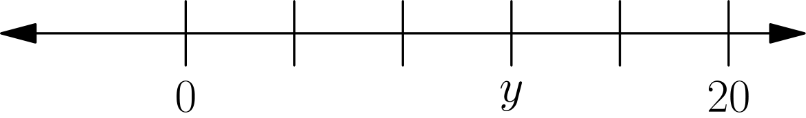
（A）3 （B）10 （C）12 （D）15 （E）16
English
If the markings on the number line shown are equally spaced, what is the number y?
(A) 3 (B) 10 (C) 12 (D) 15 (E) 16
第 7 题
20 枚二十五美分硬币和 10 枚十美分硬币的总价值，等于 10 枚二十五美分硬币和 n 枚十美分硬币的总价值。n 是多少？
（A）10 （B）20 （C）30 （D）35 （E）45
English
The value of 20 quarters and 10 dimes equals the value of 10 quarters and n dimes. What is n?
(A) 10 (B) 20 (C) 30 (D) 35 (E) 45
第 8 题
下列表达式的值是多少？
(2 × 3 × 4)(1/2 + 1/3 + 1/4)
（A）1 （B）3 （C）9 （D）24 （E）26
English
What is the value of
(2 × 3 × 4)(1/2 + 1/3 + 1/4)?
(A) 1 (B) 3 (C) 9 (D) 24 (E) 26
第 9 题
约翰逊老师的数学班中，男生与女生的比例是 2 比 3。班上一共有 30 名学生。男生占全班的百分之几？
（A）12% （B）20% （C）40% （D）60% （E）662/3%
English
There are 2 boys for every 3 girls in Ms. Johnson’s math class. If there are 30 students in her class, what percent of them are boys?
(A) 12% (B) 20% (C) 40% (D) 60% (E) 662/3%
第 10 题
七点整时，时针和分针之间较小的夹角是多少？
（A）50° （B）120° （C）135° （D）150° （E）165°
English
How many degrees are in the smaller angle between the hour hand and the minute hand of a clock that reads seven o’clock?
(A) 50° (B) 120° (C) 135° (D) 150° (E) 165°
第 11 题
下列哪个图形与所给图形关于虚线对称？
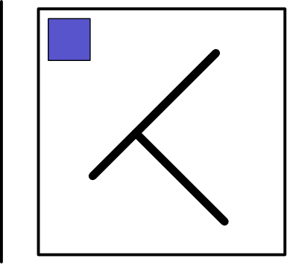
（A）<img src="/amc8/1989/11a.svg" style="max-height:6rem"/> （B）<img src="/amc8/1989/11b.svg" style="max-height:6rem"/> （C）<img src="/amc8/1989/11c.svg" style="max-height:6rem"/> （D）<img src="/amc8/1989/11d.svg" style="max-height:6rem"/> （E）<img src="/amc8/1989/11e.svg" style="max-height:6rem"/>
English
Which of the five “T-like shapes” would be symmetric to the one shown with respect to the dashed line?
(A) <img src="/amc8/1989/11a.svg" style="max-height:6rem"/> (B) <img src="/amc8/1989/11b.svg" style="max-height:6rem"/> (C) <img src="/amc8/1989/11c.svg" style="max-height:6rem"/> (D) <img src="/amc8/1989/11d.svg" style="max-height:6rem"/> (E) <img src="/amc8/1989/11e.svg" style="max-height:6rem"/>
第 12 题
下列表达式的值是多少？
(1 - 1/3)/(1 - 1/2)
（A）1/3 （B）2/3 （C）3/4 （D）3/2 （E）4/3
English
What is the value of
(1 - 1/3)/(1 - 1/2)?
(A) 1/3 (B) 2/3 (C) 3/4 (D) 3/2 (E) 4/3
第 13 题
下列哪个式子等于
9/(7 × 53)
（A）0.9/(0.7 × 53) （B）0.9/(0.7 × 0.53) （C）0.9/(0.7 × 5.3) （D）0.9/(7 × 0.53) （E）0.09/(0.07 × 0.53)
English
Which of the following is equal to
9/(7 × 53)?
(A) 0.9/(0.7 × 53) (B) 0.9/(0.7 × 0.53) (C) 0.9/(0.7 × 5.3) (D) 0.9/(7 × 0.53) (E) 0.09/(0.07 × 0.53)
第 14 题
把数字 2、4、5、6、9 分别填入这个减法算式的五个方框中，每个数字恰好用一次，可能得到的最小差是多少？
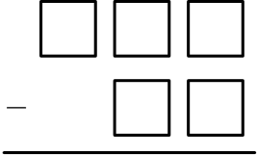
（A）58 （B）123 （C）149 （D）171 （E）176
English
When placing each of the digits 2, 4, 5, 6, 9 in exactly one of the boxes of this subtraction problem, what is the smallest difference that is possible?
(A) 58 (B) 123 (C) 149 (D) 171 (E) 176
第 15 题
如图，在平行四边形 ABCD 中，阴影区域 BEDC 的面积是多少？
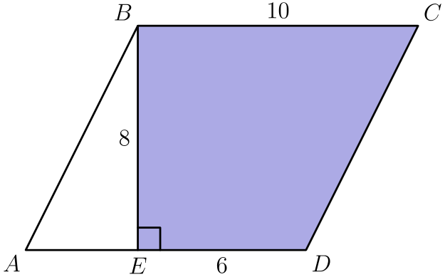
（A）24 （B）48 （C）60 （D）64 （E）80
English
In parallelogram ABCD shown, what is the area of the shaded region BEDC?
(A) 24 (B) 48 (C) 60 (D) 64 (E) 80
第 16 题
47 可以用多少种方式写成两个质数的和？
（A）0 （B）1 （C）2 （D）3 （E）多于 3
English
In how many ways can 47 be written as the sum of two primes?
(A) 0 (B) 1 (C) 2 (D) 3 (E) more than 3
第 17 题
N 是一个大于 9 且小于 17 的数。下列哪个数可能是 6、10 和 N 的平均数？
（A）8 （B）10 （C）12 （D）14 （E）16
English
The number N is between 9 and 17. Which of the following could be the average of 6, 10, and N?
(A) 8 (B) 10 (C) 12 (D) 14 (E) 16
第 18 题
计算器上有一个倒数键，按下它会把当前显示的数换成它的倒数。例如，若显示屏上是 4，按一次该键后显示 0.25。如果显示屏上是 32，至少按几次倒数键才能再次显示 32？
（A）1 （B）2 （C）3 （D）4 （E）5
English
A calculator has a reciprocal key that replaces the number currently displayed with its reciprocal. For example, if the display shows 4 and the key is pressed, the display becomes 0.25. If 32 is currently displayed, what is the fewest number of times the reciprocal key must be pressed so that the display again reads 32?
(A) 1 (B) 2 (C) 3 (D) 4 (E) 5
第 19 题
图中曲线表示冲浪城政府在 1988 年的累计花费，单位为百万美元。例如，截至二月初约已花费 0.5 百万美元，截至四月底约已花费 2 百万美元。六月、七月和八月大约一共花费了多少百万美元？
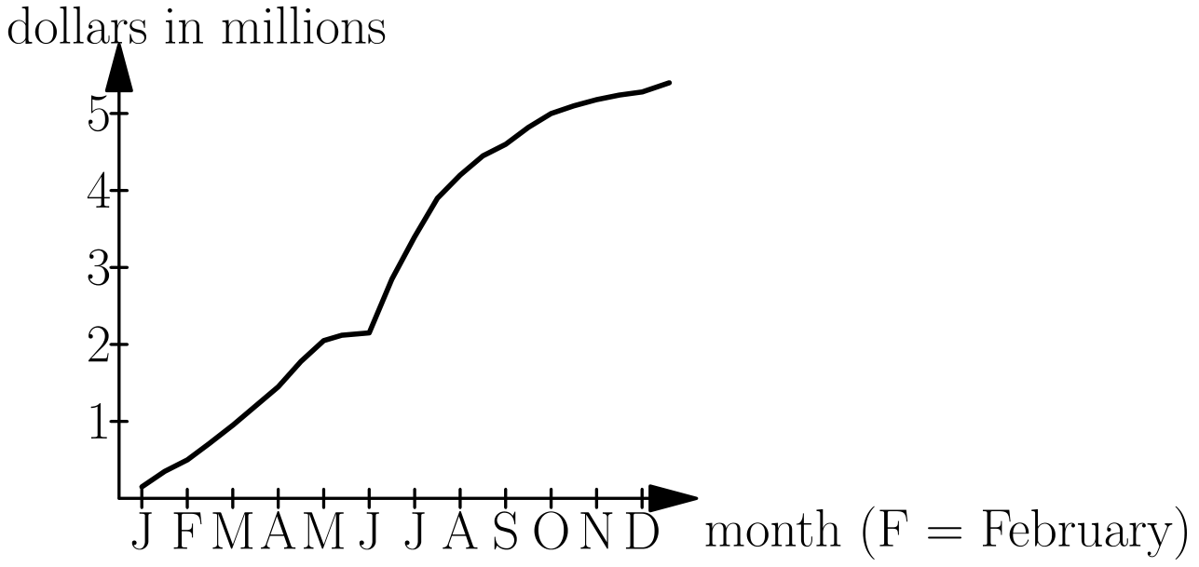
（A）1.5 （B）2.5 （C）3.5 （D）4.5 （E）5.5
English
The graph below shows the total accumulated dollars (in millions) spent by the Surf City government during 1988. For example, about 0.5 million had been spent by the beginning of February and approximately 2 million by the end of April. Approximately how many millions of dollars were spent during the summer months of June, July, and August?
(A) 1.5 (B) 2.5 (C) 3.5 (D) 4.5 (E) 5.5
第 20 题
图中的展开图折成一个数字立方体。在立方体的每个顶点，都会有三个面相交。相交于同一个顶点的三个面上的数字，可能得到的最大和是多少？
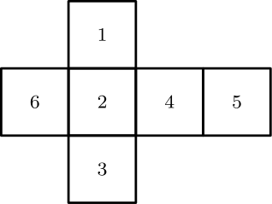
（A）11 （B）12 （C）13 （D）14 （E）15
English
The figure shown may be folded along the lines to form a number cube. Three faces come together at each corner of the cube. What is the largest sum of three numbers whose faces come together at a corner?
(A) 11 (B) 12 (C) 13 (D) 14 (E) 15
第 21 题
杰克有一袋 128 个苹果。他先把其中的 25% 卖给吉尔。接着，他又把袋中剩余苹果的 25% 卖给琼。之后，他把袋中剩下的苹果中最亮的一个送给了老师。最后袋中还剩多少个苹果？
（A）7 （B）63 （C）65 （D）71 （E）111
English
Jack had a bag of 128 apples. He sold 25% of them to Jill. Next he sold 25% of those remaining to June. Of those apples still in his bag, he gave the shiniest one to his teacher. How many apples did Jack have then?
(A) 7 (B) 63 (C) 65 (D) 71 (E) 111
第 22 题
字母 A、J、H、S、M、E 和数字 1、9、8、9 分别循环移动，每次移动一位，用来组成一个编号列表。从 AJHSME 1989 开始，列表的第 1 行是 JHSMEA 9891，第 2 行是 HSMEAJ 8919，第 3 行是 SMEAJH 9198，依此类推。AJHSME 1989 第一次会出现在第几行？
（A）6 （B）10 （C）12 （D）18 （E）24
English
The letters A, J, H, S, M, E and the digits 1, 9, 8, 9 are each cycled separately (shifted one place at a time) to build a numbered list. Starting from AJHSME 1989, the list begins: line 1 is JHSMEA 9891, line 2 is HSMEAJ 8919, line 3 is SMEAJH 9198, and so on. On what numbered line will AJHSME 1989 appear for the first time?
(A) 6 (B) 10 (C) 12 (D) 18 (E) 24
第 23 题
一位艺术家有 14 个边长为 1 米的正方体。她把它们放在地面上，搭成如图所示的雕塑，然后给雕塑露出的表面上漆。她一共要漆多少平方米？
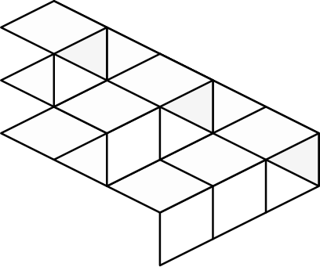
（A）21 （B）24 （C）33 （D）37 （E）42
English
An artist has 14 cubes, each with an edge of 1 meter. She stands them on the ground to form a sculpture as shown. She then paints the exposed surface of the sculpture. How many square meters does she paint?
(A) 21 (B) 24 (C) 33 (D) 37 (E) 42
第 24 题
把一张正方形纸沿竖直方向对折，再沿图中的虚线把折好的纸剪成两半。这样会得到三个长方形：一个大长方形和两个小长方形。一个小长方形的周长与大长方形周长之比是多少？
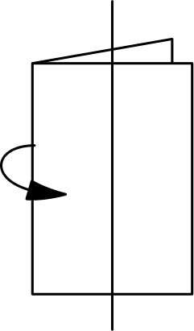
（A）1/2 （B）2/3 （C）3/4 （D）4/5 （E）5/6
English
Suppose a square piece of paper is folded in half vertically. The folded paper is then cut in half along the dashed line. Three rectangles are formed—a large one and two small ones. What is the ratio of the perimeter of one of the small rectangles to the perimeter of the large rectangle?
(A) 1/2 (B) 2/3 (C) 3/4 (D) 4/5 (E) 5/6
第 25 题
每次转动图中的两个转盘时，两个指针各选出一个数。所选两个数之和为偶数的概率是多少？
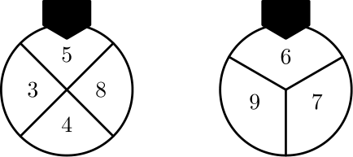
（A）1/6 （B）3/7 （C）1/2 （D）2/3 （E）5/7
English
Every time the two wheels shown are spun, two numbers are selected by the pointers. What is the probability that the sum of the two selected numbers is even?
(A) 1/6 (B) 3/7 (C) 1/2 (D) 2/3 (E) 5/7

第二部分 解答
答案速查：
题号 1 2 3 4 5 6 7 8 9
答案 E D A E D C D E C
题号 10 11 12 13 14 15 16 17 18
答案 D B E A C D A B B
题号 19 20 21 22 23 24 25
答案 B D D C C E C
答案串：EDAEDCDECDBEACDABBBDDCCEC
第 1 题 答案 E
把各项配对，使每一对的和都是 50：1 + 49、11 + 39、21 + 29、31 + 19、41 + 9。
一共有 5 对，所以总和是 5 × 50 = 250。
所以正确答案是 <b>E</b>。
English
Pair the terms so each pair sums to 50: 1 + 49, 11 + 39, 21 + 29, 31 + 19, and 41 + 9.
There are 5 such pairs, so the total is 5 × 50 = 250.
Thus, the correct answer is <b>E</b>.
第 2 题 答案 D
这三个分数分别表示不同数位上的小数：2/10 = 0.2，4/100 = 0.04，6/1000 = 0.006。
相加得 0.2 + 0.04 + 0.006 = 0.246。
所以正确答案是 <b>D</b>。
English
Each fraction is a decimal in a different place: 2/10 = 0.2, 4/100 = 0.04, and 6/1000 = 0.006.
Adding these gives 0.2 + 0.04 + 0.006 = 0.246.
Thus, the correct answer is <b>D</b>.
第 3 题 答案 A
把这些数都写成四位小数：0.9900、0.9099、0.9000、0.9090、0.9009。
从左向右比较可知，0.9900 的百分位数字最大，所以 0.99 最大。
所以正确答案是 <b>A</b>。
English
Write each number with four decimal places: 0.9900, 0.9099, 0.9000, 0.9090, 0.9009.
Comparing from the left, 0.9900 has the largest hundredths digit, so 0.99 is the largest.
Thus, the correct answer is <b>A</b>.
第 4 题 答案 E
把分子和分母分别取成便于计算的近似数，得到 401/0.205 ≈ 400/0.2。
由于 400/0.2 = 2000，原数最接近 2000。
所以正确答案是 <b>E</b>。
English
Round the numerator and denominator: 401/0.205 ≈ 400/0.2.
Since 400/0.2 = 2000, the value is closest to 2000.
Thus, the correct answer is <b>E</b>.
第 5 题 答案 D
先算括号：6 ÷ 3 = 2。再做乘法，9 × 2 = 18。
最后 -15 + 18 = 3。
所以正确答案是 <b>D</b>。
English
Inside the parentheses, 6 ÷ 3 = 2. Then multiplication comes before addition, so 9 × 2 = 18.
Finally, -15 + 18 = 3.
Thus, the correct answer is <b>D</b>.
第 6 题 答案 C
从 0 到 20 被分成 5 个相等间隔，所以每个间隔的长度是 20/5 = 4。
y 距 0 有 3 个间隔，所以 y = 3 × 4 = 12。
所以正确答案是 <b>C</b>。
English
From 0 to 20 there are 5 equal spaces, so each space is 20/5 = 4.
The mark labeled y is 3 spaces from 0, so y = 3 × 4 = 12.
Thus, the correct answer is <b>C</b>.
第 7 题 答案 D
20 枚二十五美分硬币和 10 枚十美分硬币的总价值是 $5.00 + $1.00 = $6.00。
十枚二十五美分硬币值 $2.50，所以 n 枚十美分硬币必须值 $6.00 - $2.50 = $3.50。这相当于 35 枚十美分硬币，因此 n = 35。
所以正确答案是 <b>D</b>。
English
The value of 20 quarters and 10 dimes is $5.00 + $1.00 = $6.00.
Ten quarters are worth $2.50, so the n dimes must supply $6.00 - $2.50 = $3.50. That is 35 dimes, so n = 35.
Thus, the correct answer is <b>D</b>.
第 8 题 答案 E
2 × 3 × 4 = 24，所以原式等于 24 · 1/2 + 24 · 1/3 + 24 · 1/4。
这等于 12 + 8 + 6 = 26。
所以正确答案是 <b>E</b>。
English
Since 2 × 3 × 4 = 24, distribute it over the sum: 24 · 1/2 + 24 · 1/3 + 24 · 1/4.
This equals 12 + 8 + 6 = 26.
Thus, the correct answer is <b>E</b>.
第 9 题 答案 C
男生占每 2 + 3 = 5 名学生中的 2 名，也就是全班的 2/5。全班共有 30 人这一信息其实不必使用。
化成百分数，2/5 = 40%。
所以正确答案是 <b>C</b>。
English
Boys make up 2 out of every 2 + 3 = 5 students, which is 2/5 of the class. The total of 30 students is not even needed.
As a percent, 2/5 = 40%.
Thus, the correct answer is <b>C</b>.
第 10 题 答案 D
钟面上的 12 个数字把一周分成 12 等份，每份是 (360°)/12 = 30°。
七点整时，分针指向 12，时针指向 7。沿较短方向相隔 5 个刻度，所以角度是 5 × 30° = 150°。
所以正确答案是 <b>D</b>。
English
The 12 numbers divide the clock into 12 equal sections of (360°)/12 = 30° each.
At seven o’clock the hands point to 12 and 7, which are 5 sections apart the short way, giving 5 × 30° = 150°.
Thus, the correct answer is <b>D</b>.
第 11 题 答案 B
两个图形关于虚线对称，指的是沿这条线把纸折起来后，一个图形恰好落在另一个图形上。关于竖直虚线反射时，图形的左、右位置互换，上、下位置保持不变。
在这个反射下，原图中左上角的小方块会移到右上角，中间那条横杆的倾斜方向会相反，而原本朝右下方伸出的竖杆必须改为朝左下方伸出。只有一个选项同时具备这三个特征。
所以正确答案是 <b>B</b>。
English
Two figures are symmetric with respect to the dashed line when folding the paper along that line makes one coincide with the other. Reflecting across the vertical dashed line swaps left and right while leaving top and bottom unchanged.
Under this reflection the small square in the top-left corner moves to the top-right corner, the straight crossbar reverses its slant, and the stem that points down and to the right must instead point down and to the left. Only one choice has all three of these features.
Thus, the correct answer is <b>B</b>.
第 12 题 答案 E
分子是 1 - 1/3 = 2/3，分母是 1 - 1/2 = 1/2。
因此 2/3 ÷ 1/2 = 2/3 × 2 = 4/3。
所以正确答案是 <b>E</b>。
English
The numerator is 1 - 1/3 = 2/3, and the denominator is 1 - 1/2 = 1/2.
Dividing gives 2/3 ÷ 1/2 = 2/3 × 2 = 4/3.
Thus, the correct answer is <b>E</b>.
第 13 题 答案 A
将分子 9 除以 10，得到 0.9。为了保持分数值不变，分母整体也要除以 10，即把其中一个因数除以 10。
把分母中的因数 7 除以 10，而另一个因数保持不变，便得到 0.9/(0.7 × 53)。其他选项会使原式改变 10 倍或 100 倍。
所以正确答案是 <b>A</b>。
English
To rewrite the numerator 9 as 0.9, divide it by 10. To keep the fraction equal, divide the denominator by 10 too, which means dividing one of its factors by 10.
Dividing the factor 7 by 10 gives 0.9/(0.7 × 53), which equals the original. Each other choice changes the value by a factor of 10 or 100.
Thus, the correct answer is <b>A</b>.
第 14 题 答案 C
差最小时，上面的三位数应尽量小，下面要减去的两位数应尽量大。
最大的两位数是 96，使用数字 9 和 6。剩下的数字 2、4、5 能组成的最小三位数是 245，所以最小差是 245 - 96 = 149。
所以正确答案是 <b>C</b>。
English
The difference is smallest when the three-digit number (the top) is as small as possible and the two-digit number (subtracted) is as large as possible.
The largest two-digit number is 96, using the digits 9 and 6. The smallest three-digit number from the remaining digits 2, 4, 5 is 245. So the smallest difference is 245 - 96 = 149.
Thus, the correct answer is <b>C</b>.
第 15 题 答案 D
平行四边形的底为 10，高为 8，所以面积是 10 × 8 = 80。
未涂色三角形 ABE 的底为 AE = AD - ED = 10 - 6 = 4，高为 8，所以面积是 1/2 × 4 × 8 = 16。阴影面积是 80 - 16 = 64。
所以正确答案是 <b>D</b>。
English
The parallelogram has base 10 and height 8, so its area is 10 × 8 = 80.
The unshaded triangle ABE has base AE = AD - ED = 10 - 6 = 4 and height 8, so its area is 1/2 × 4 × 8 = 16. The shaded area is 80 - 16 = 64.
Thus, the correct answer is <b>D</b>.
第 16 题 答案 A
因为 47 是奇数，若两个质数的和等于 47，其中必有一个偶质数。唯一的偶质数是 2。
于是另一个数必须是 47 - 2 = 45，但 45 = 9 × 5，不是质数。因此没有这样的表示方式。
所以正确答案是 <b>A</b>。
English
Since 47 is odd, a sum of two primes equal to 47 needs one even prime and one odd prime. The only even prime is 2.
That would require the other number to be 47 - 2 = 45, but 45 = 9 × 5 is not prime. So there is no way.
Thus, the correct answer is <b>A</b>.
第 17 题 答案 B
平均数为 (6 + 10 + N)/3 = (16 + N)/3。当 N = 9 时，这个式子为 25/3 ≈ 8.3；当 N = 17 时，它等于 11。
所以平均数严格介于约 8.3 和 11 之间。选项中只有 10 落在这个范围内。
所以正确答案是 <b>B</b>。
English
The average is (6 + 10 + N)/3 = (16 + N)/3. When N = 9 this is 25/3 ≈ 8.3, and when N = 17 it is 11.
So the average lies strictly between about 8.3 and 11. Among the choices, only 10 falls in this range.
Thus, the correct answer is <b>B</b>.
第 18 题 答案 B
从 32 开始，按一次倒数键会得到 1/32。
再按一次，就是对倒数再取倒数，得到 1/(1/32) = 32。所以最少需要按 2 次。
所以正确答案是 <b>B</b>。
English
Pressing the key once changes 32 to its reciprocal 1/32.
Pressing it a second time takes the reciprocal again, returning to 1/(1/32) = 32. So 2 presses are enough.
Thus, the correct answer is <b>B</b>.
第 19 题 答案 B
图显示的是累计花费，所以六月、七月、八月的花费等于这段时间累计值的增加量。
从图上看，六月开始时累计值略多于 2 百万美元，八月结束时略多于 4.5 百万美元，差约为 4.5 - 2 = 2.5 百万美元。
所以正确答案是 <b>B</b>。
English
The graph gives the total accumulated spending, so the amount spent during June, July, and August equals the accumulated total at the end of August minus the accumulated total at the beginning of June.
The curve is at a bit more than 2 million at the beginning of June and a bit more than 4.5 million by the end of August. The difference is about 4.5 - 2 = 2.5 million.
Thus, the correct answer is <b>B</b>.
第 20 题 答案 D
折成立方体后，相对面不能在同一个顶点相遇。由展开图可判断相对面为 1 与 3、2 与 5、4 与 6。
要让三个相邻面的和最大，就从每对相对面中取较大的数 3、5 和 6。它们可以在同一个顶点相遇，和为 3 + 5 + 6 = 14。
所以正确答案是 <b>D</b>。
English
When the net is folded, the pairs of opposite faces are 1 and 3, 2 and 5, and 4 and 6. Three faces meeting at a corner must come one from each opposite pair.
To maximize the sum, take the larger number from each pair: 3, 5, and 6. These three faces do meet at a corner, and their sum is 3 + 5 + 6 = 14.
Thus, the correct answer is <b>D</b>.
第 21 题 答案 D
杰克第一次卖掉 25% 后，剩下 3/4 × 128 = 96 个苹果。第二次又卖掉余数的 25%，剩下 3/4 × 96 = 72 个苹果。
再送给老师 1 个后，剩下 72 - 1 = 71 个。
所以正确答案是 <b>D</b>。
English
After selling 25% to Jill, Jack keeps 3/4 × 128 = 96 apples. After selling 25% of those to June, he keeps 3/4 × 96 = 72 apples.
He then gives 1 to his teacher, leaving 72 - 1 = 71.
Thus, the correct answer is <b>D</b>.
第 22 题 答案 C
字母串 AJHSME 每移动 6 次回到原顺序，数字串 1989 每移动 4 次回到原顺序。
两者第一次同时回到原样是在 6 和 4 的最小公倍数 12 次移动后。因此 AJHSME 1989 第一次出现在第 12 行。
所以正确答案是 <b>C</b>。
English
The six letters cycle back to their original order AJHSME every 6 lines, and the four digits cycle back to 1989 every 4 lines.
Both happen on the same line at the least common multiple of 6 and 4, which is 12. So AJHSME 1989 first reappears on line 12.
Thus, the correct answer is <b>C</b>.
第 23 题 答案 C
因为每一层都靠齐在同一个角上，所以从每个竖直方向看，露出的阶梯侧面都是 3 + 2 + 1 = 6 个小正方形面，四个方向共 4 × 6 = 24 个侧面。
从上方看，露出的顶面覆盖整个 3 × 3 的底面投影，所以顶面积是 9 平方米。底面不漆，因此总上漆面积是 24 + 9 = 33 平方米。
所以正确答案是 <b>C</b>。
English
Because each higher layer is flush into one corner, each of the four vertical sides shows a stepped profile of 3 + 2 + 1 = 6 exposed square faces, for 4 × 6 = 24 side faces.
Viewed from directly above, the top faces cover the full 3 × 3 footprint, adding 9 more faces. The bottom rests on the ground and is not painted, so the total is 24 + 9 = 33 square meters.
Thus, the correct answer is <b>C</b>.
第 24 题 答案 E
设原正方形边长为 4。对折后得到一个 2 × 4 的双层长方形，再用一条与折痕平行的线把折好的纸切开，分成含折痕的一条和不含折痕的一条。
含折痕的那块展开后是 2 × 4 的大长方形，周长为 2(2 + 4) = 12。另一块展开后成为两个 1 × 4 的小长方形，每个周长为 2(1 + 4) = 10。所求比为 10/12 = 5/6。
所以正确答案是 <b>E</b>。
English
Let the square have side 4. Folding in half makes a 2 × 4 stack of two layers. Cutting parallel to the fold splits it into a strip containing the fold and a strip that does not.
The strip with the fold unfolds into the large rectangle, 2 × 4, with perimeter 2(2 + 4) = 12. The other strip is two separate small rectangles, each 1 × 4, with perimeter 2(1 + 4) = 10. The ratio is 10/12 = 5/6.
Thus, the correct answer is <b>E</b>.
第 25 题 答案 C
和为偶数需要两个数同奇偶。第一个转盘的偶数为 {4, 8}，奇数为 {3, 5}，所以两种奇偶性的概率都是 2/4 = 1/2。第二个转盘的偶数为 {6}，概率为 1/3；奇数为 {7, 9}，概率为 2/3。
因此和为偶数的概率是 1/2 · 1/3 + 1/2 · 2/3 = 1/6 + 2/6 = 1/2。
所以正确答案是 <b>C</b>。
English
The sum is even when both numbers are even or both are odd. The first wheel has evens {4, 8} and odds {3, 5}, each with probability 2/4 = 1/2. The second wheel has even {6} with probability 1/3 and odds {7, 9} with probability 2/3.
So the probability of an even sum is 1/2 · 1/3 + 1/2 · 2/3 = 1/6 + 2/6 = 1/2.
Thus, the correct answer is <b>C</b>.

